**Building Independence: Teaching Children to Put on Their Own Shoes**

**– And get them on the right feet!**

There really are no tricks to teaching children to put their shoes on their feet. It’s really something that takes practice, and some strength throughout their bodies. Strength? It doesn’t seem like anyone has to be strong to put on shoes! But it actually does require that muscles are the body are strong enough for the child to hold his/her body upright and balanced as they reach to put their shoes on their feet. Children develop this strength in everyday play such as running, jumping, climbing the stairs for a slide, riding on a swing, riding a tricycle, carrying a basket of toys,….really all activities that require them to use the muscles in their body.

If your child is having some trouble learning to get shoes on, he/she can practice with slippers or other loose-fitting shoes. Even shoes from an older sibling or parent can be used for practice.

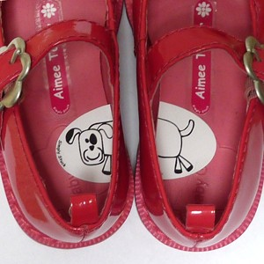Here is a trick, however, for teaching your child to get their shoes on the correct feet. Find a large sticker and cut it in half. Stick it to the inside of the shoes so that when the shoes are placed side by side with the left on the left and the right on the right, the sticker halves match up.